XPREAM

# KONTROL PERUBAHAN BLUEPRINT

|  |  |  |
| --- | --- | --- |
| **Document Version** | **Change Date** | **Description** |
|  |  |  |
|  |  |  |
|  |  |  |

# HALAMAN PENGESAHAN

DAFTAR ISI

KONTROL PERUBAHAN BLUEPRINT 2

HALAMAN PENGESAHAN 3

1. Background 5

2. Goals 5

3. Scope of Work 5

3.1. Scope 5

3.2. Sitemap/Mind Map 5

4. Desain System 6

4.1. Use Case 6

4.2. Flow Process Business & System 6

4.2.1. Flow Process Login 7

4.2.2. Flow Process Track Your Co 8

4.2.3. Flow Process Experience 10

4.2.4. Flow Process Tools 12

4.2.5. Flow Process Equipment 14

4.2.6. Flow Process My Profile 14

4.3. Application’s Mockup 20

4.3.1. Module Login 20

4.3.2. Module Track Your Co 20

4.3.3. Module Experience 20  
4.3.4. Module Tools 20  
4.3.5. Module Equipment 20  
4.3.6. Module Profile 20

4.4. Desain Database 20

4.5. Role Matrix 20

Lampiran 21

## Background

Sistem XPREAM (Excellent Project Management System) sudah diimplementasikan di beberapa dinas di GMF

## Goals

Menampilkan dashboard untuk memonitoring

## Scope of Work

### Scope

|  |  |
| --- | --- |
| **Page** | **Description** |
| Dashboard | Page to monitor engine/APU components |
| Upload | Page to upload progress Gate 4 & 5 |

### Sitemap/Mind Map

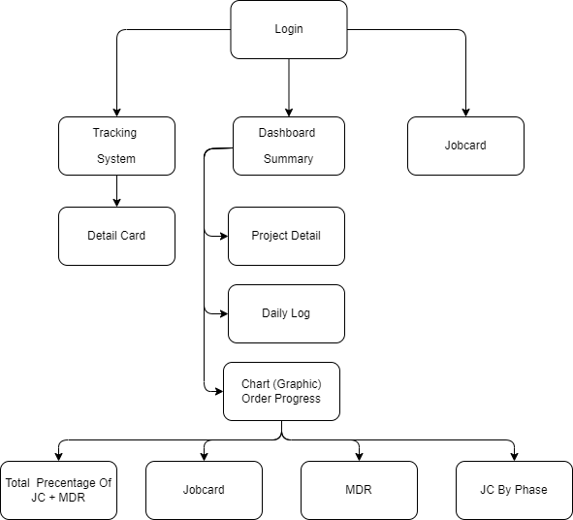

## Desain System

### Use Case

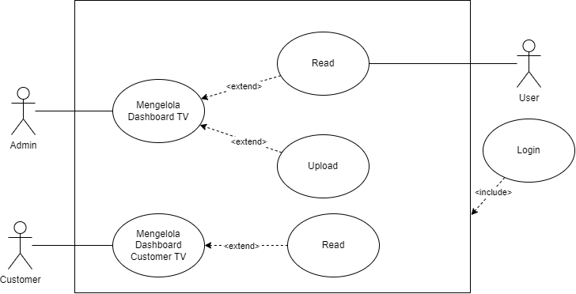

### Flow Process Business & System

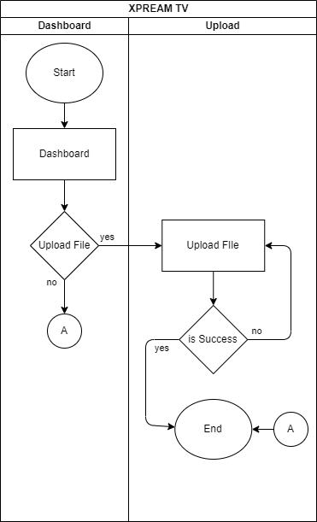

#### Flow Process Login

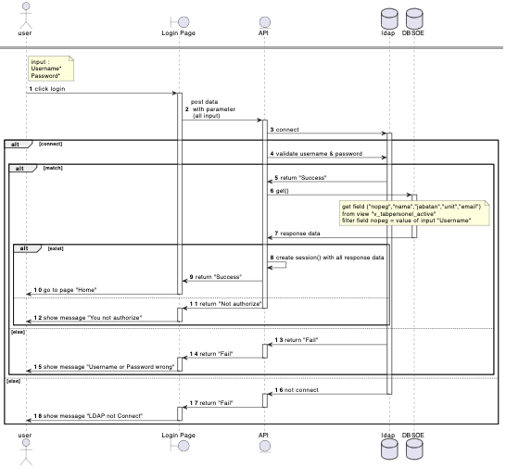

#### Flow Process Dashboard Admin

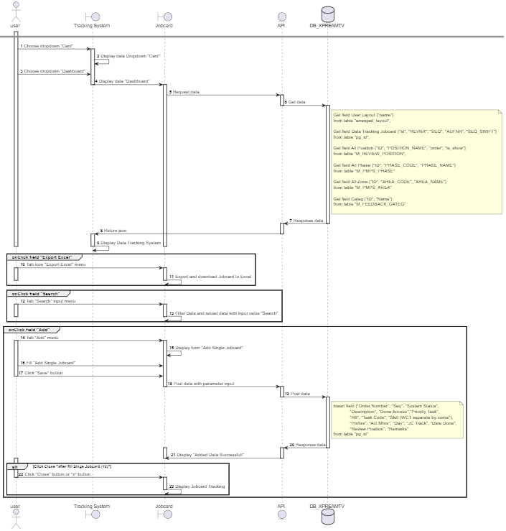

#### Flow Process Jobcard Tracking System



#### Flow Process Dashboard Customers

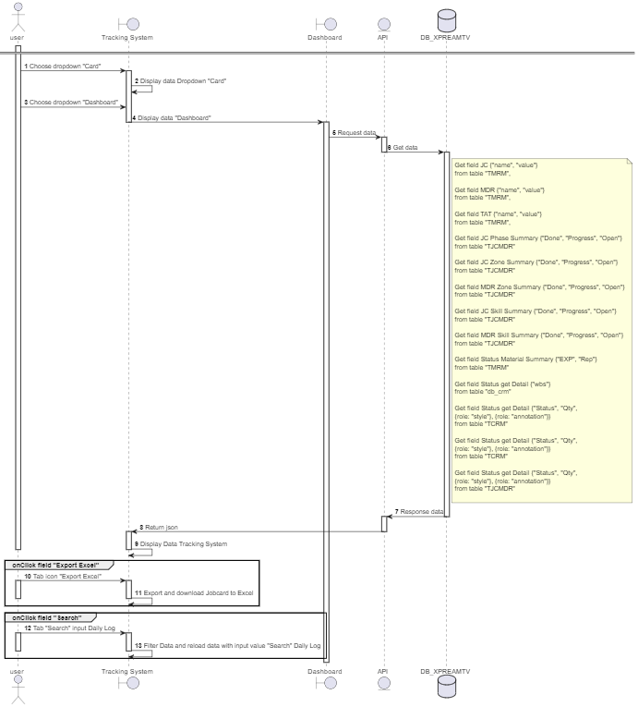

### Application’s Mockup

#### Style Guide

|  |  |  |  |  |  |
| --- | --- | --- | --- | --- | --- |
| Primary Color | | | | | |
| Main | Surface | Border | Hover | Pressed | Focus |
| #006298 | #F6F9FE | #BAD5F9 | #276BC5 | #184076 | #CCDFEA |
|  |  |  |  |  |  |
| Secondary Color | | | | | |
| Green | Yellow | Red | Gray | White | Black |
| #84BD00 | #E2B93B | #EB5757 | #EDEDED | #FFFFFF | #0A0A0A |

#### Home

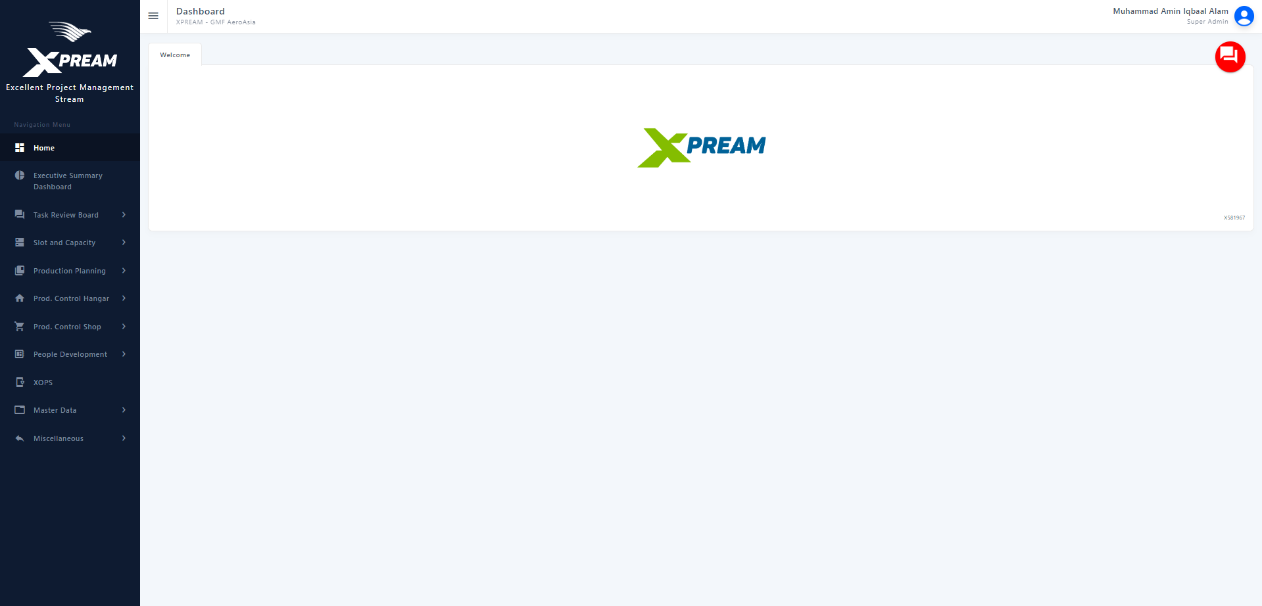

#### Dashboard Admin

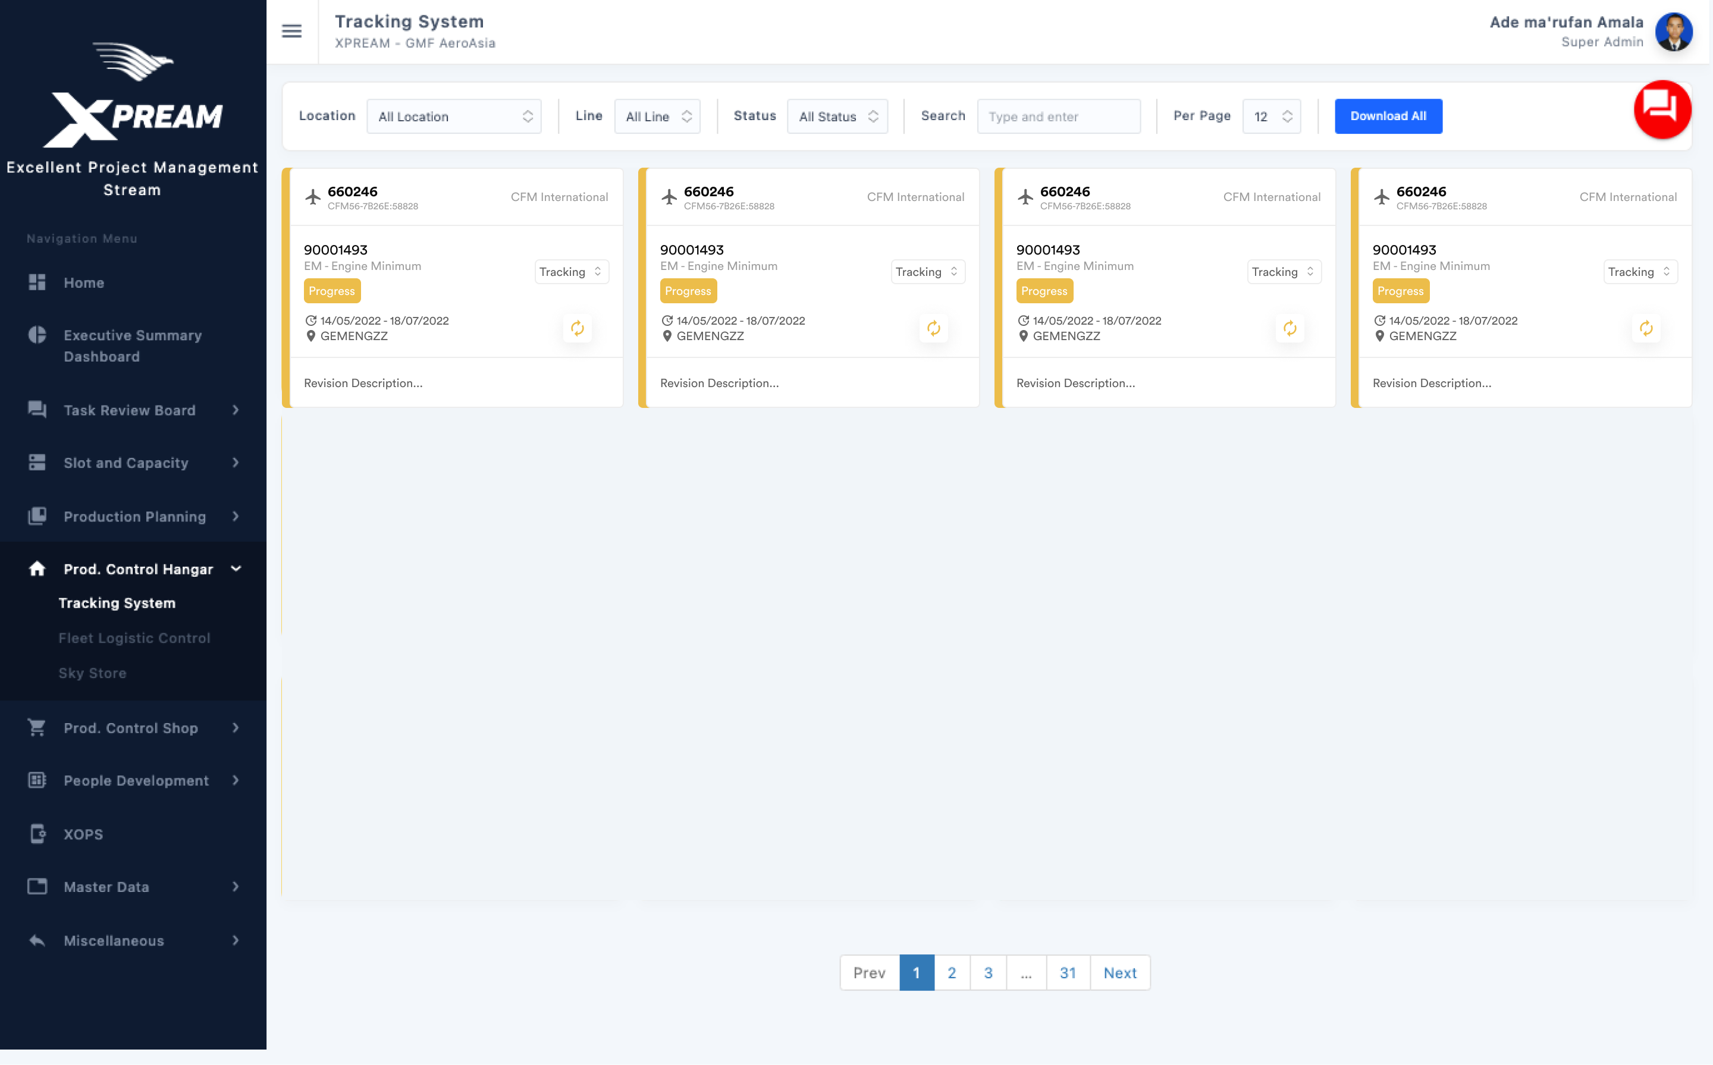

#### Dashboard Customer

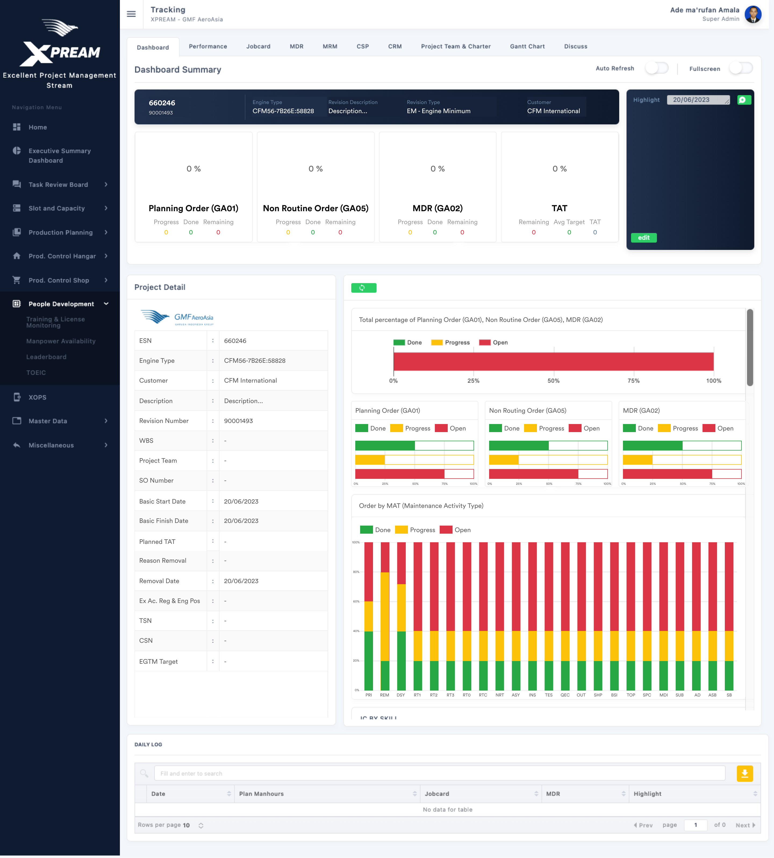

#### Upload File



### Desain Database

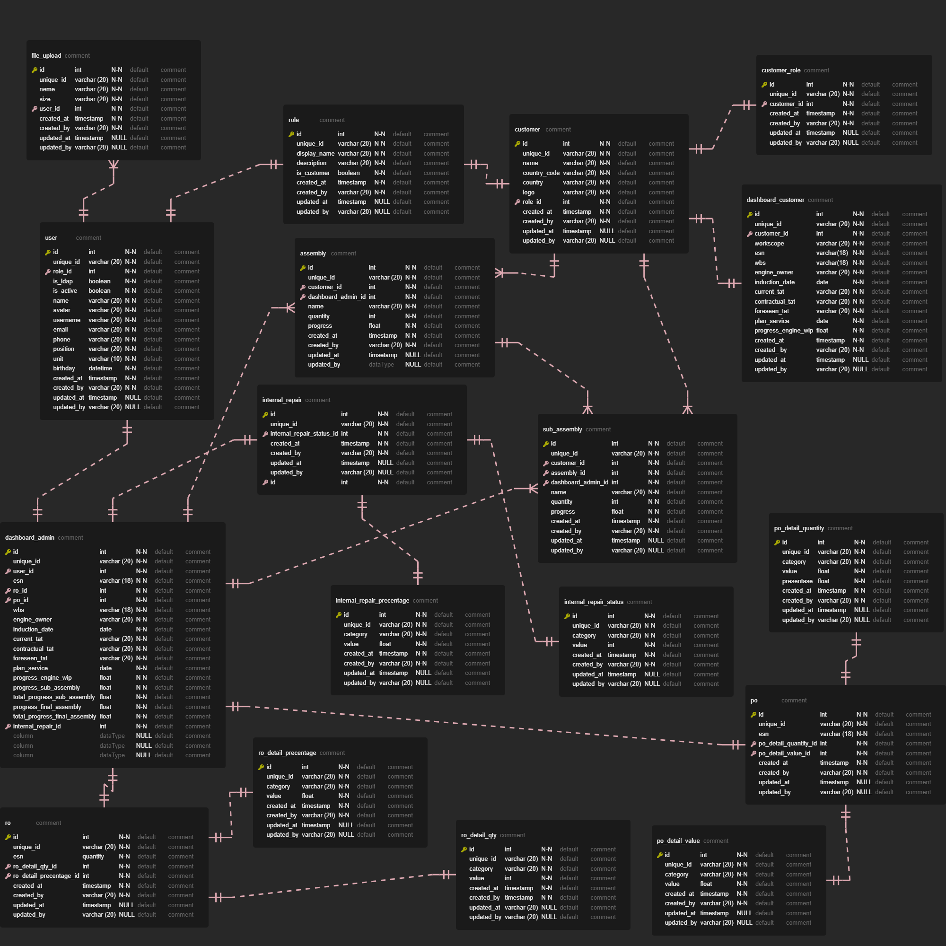

### Role Matrix

Untuk Sementara hanya bisa diakses unit TV dan Customers

# Lampiran

1. Link Mockup :

<https://www.figma.com/file/15n0QeA4j9eP2qtyjFZ9J3/IERApps?node-id=0%3A1&t=8IIaMp0YGagvdjXo-3>